Final Project:

Predicting Whether or Not There Will Be Precipitation the Next Day

Machine Learning Workflow

By: Hasan Hindi

Date: 3/13/2020

Executive Summary

For the final project that I am tasked with, I elected to examine the weather.csv file and performed statistical analysis and executed a machine learning workflow to see whether it was possible to predict if there will be Precipitation the next day based on several predictors. Prior to running any models, data pre-processing and feature engineering needed to be performed on the dataset to clean it and prepare it for modeling.
Class imbalance was an issue with the existing dataset based on electing to use the text feature as whether there was precipitation on a given day or not. This was seen during the first model evaluation results of the Random Forest algorithm. The metrics such as the accuracy were at first glance pretty high indicating good performance, however it was misleading due to the imbalance (85% No Precipitation/15% Precipitation). Since we cared about predicting precipitation, this model would not suffice since it failed to beat the naïve (NIR) baseline score computed in the confusion matrix function.
To tackle on the imbalance, I elected to use a different feature to determine whether there was precipitation on a given day or not, “Observed Daily Water Equivalent Inches.” This gave us a revised split of 58% no precipitation/42% Precipitation which resembled the actual weather behavior of the Northwest region of the USA. From here, I elected to make some minor changes by utilizing frequency encoding of the categorical variables such as month, station, and the Precipitation columns that were created(today, yesterday and two days ago). In addition, all predictor variables were scaled based on the mean and sd of their respective columns.
A RF model and NN model were performed with 10% training set due to the computing time it would take to run the models. The RF model was executed with three variations of “mtry” which were the recommended value for a classification target variable as well as ±2. With the NN model, 10 fold CV was utilized for a total of 5 times with different sizes of nodes (8:10) with a decay of 0.2.
The results between both models showed an improvement over the first RF model executed. The accuracy scores were lower, however both were improvements over the revised NIR which the first model failed to do. In addition to this, the True Positive Rate (sensitivity) was a disappointing 0.2 for the first model, but with the change implemented for the class imbalance this improved drastically to 0.65 for the second RF model and 0.69 for the Neural network model. Lastly, the AUC of the ROC curves for both were improvements over the first RF model. To assess which model performed the best, the second RF model and the NN model were fairly close with their respective results. However, since maximizing the predictive power of whether or not there will be precipitation the next day, the NN model is superior since the TPR is higher and has similar accuracy and AUC scores of the second RF model.

Analytical Plan

For the following project, I will be utilizing the “Weather.CSV dataset provided for us in order to conduct an analytical study on predicting a target feature of choice. The dataset initially contains 65,535 observations along with 113 features. There are 10 years of weather historical data for 18 weather stations in the Pacific Northwest region of the United States. To begin, we will propose an analytical plan which will consider the data analytic objectives in the context of the available data, data analytic approaches and techniques, and the expected analytic and informational outcomes. The analytic plan will seek to address the following questions:
- What are the business/research questions to be answered? What are the expected informational outcomes to be produced?
- What data (in terms of source and content) is available? What specific metrics (variables) are of interest and why? What are the expected due diligence, feature engineering, and other data review and correction steps?
- What is the general analytic goal (e.g., categorization, prediction, etc.)? What the type of learning (e.g., supervised, unsupervised, etc.) should be used, and why? What specific data analytic algorithm (e.g., neural networks, random forest, etc.) should be used, and why?
- What are the expected analytic outcomes (e.g., prediction-focused analysis using logistic regression will produce record/customer specific probabilities)?
- What is the proposed result validation approach?
With the objectives clearly listed above, I will seek to discuss in detail each question by providing explanations of what analytical approaches I will conduct along with the stated business intention of performing this analysis.

What are the business/research questions to be answered? What are the expected informational outcomes to be produced?

To tackle this question, I first decided to browse through the csv file that contains all recorded instances and features. The “READ ME” excel workbook file contains all features along with a description of what they are. A vast majority of them are numerical observations related to the weather of each day. The final feature however, “Predominant Weather Text” will be used to create the target variable, “Precipitation Tomorrow.” Feature engineering will have to be involved here in order to create this feature based on the given observation’s Weather Text description. For example, if a station on 1/10/2000 had a weather description that involved precipitation but on 1/11/2000 its weather description was “clear sky,” then the observation for 1/10/2000 would have “No Precipitation” for the target variable. The research question of whether there will be a form of precipitation tomorrow will allow us to better plan for inclement weather. Given several other inputs for an observation, a model will be conducted to allow us to create a solution to this question. The expected informational outcomes to be produced will allow us to compare how effective our model will perform based on historical data.

What data (in terms of source and content) is available? What specific metrics (variables) are of interest and why? What are the expected data due diligence, feature engineering, and other data review and correction steps?

All features listed will not be of interest to this analytical study. There are features that will need to be manipulated in order to extract information of interest. For example, the date feature is in month-day-year format, however only the month will be of interest given that it plays a role in whether or not there is a higher probability of precipitation for a given observation. For the outlined data feature engineering, data review and correction steps that need to be performed, I will look into excluding features that have a high number of NA values, impute missing values of features based on subgroups (‘Station’) and create new features that list whether or not precipitation was present yesterday, two days before and of course the target variable, tomorrow. Since we will be using the Predominant weather text to create our target variable, we will need to examine the levels and assign it based on the text description on whether or not it falls into precipitation or no precipitation. A step that is critical however prior to training our model is to ensure we are creating the target feature’s outcomes for an observation based on what station it belongs to. The dataset has 10 years of historical weather data for 18 weather stations. Therefore, it is important to take each station into consideration when performing this data feature engineering step.

What is the general analytic goal (e.g., categorization, prediction, etc.)? What the type of learning (e.g., supervised, unsupervised, etc.) should be used, and why? What specific data analytic algorithm (e.g., neural networks, random forest, etc.) should be used, and why?

The general analytic goal is to predict a target feature which will be a binary classification (Precipitation, No Precipitation). The type of learning that will be using is supervised given that there is a target feature of interest. The specific data analytic algorithm that I will be applying is Random Forest classification. Random Forest classification uses a large number of relatively uncorrelated trees that operate as an ensemble. Each individual tree in the random forest spits out a class prediction and the class with the most votes becomes our model’s prediction. I will likely compare the results of the Random Forest algorithm with another supervised learning algorithm such as Neural Networks.

What are the expected analytic outcomes (e.g., prediction-focused analysis using logistic regression will produce record/customer specific probabilities)?

The expected analytic outcomes of the random forest model will produce the final classification of an observation which I can test the performance of the model through a confusion matrix. Not only is overall accuracy an important metric for evaluation, however since we are interested in whether or not there will be precipitation the next day, we will also be making sure that an imbalanced dataset that has a vast majority of No precipitation does not mislead us into thinking our model is sufficient. True Positive Rate and False Positive Rate are of interest to us as well. I will also seek to experiment with the hyper parameters to try and fine tune the model in order to maximize accuracy while simultaneously trying to prevent overfitting. Some hyper parameters that I can think of for random forest are the number of trees and finding the optimal ‘Mtry.’Also, I will include a variable importance plot to help me understand the importance of each variable. Two measures of variable importance will be reported: one based on the mean decrease of accuracy in predictions on the out of bag samples when a given variable is excluded from the model. The other is a measure of the total decrease in node impurity that results from splits over a variable averaged across all trees.

What is the proposed result validation approach?

The proposed result validation approach will be to utilize a train/test temporal split. Given that this is a time series-based dataset, the year of the date of each observation will allow me to create this split, however it will be excluded as a feature when performing the algorithm. Lastly, a ROC curve and AUC score will also be part of the result validation approach as well.

Data Exploration & Approach

Feature Engineering

To reiterate, the objective of building a model was to predict whether there will be precipitation the next day or not. With that being said, feature engineering and data cleansing needed to be performed prior to running our model and evaluating its performance. The next step was to perform a summary function in order to observe the NA totals for every feature. There were several features that had only 3 or 4 NA values, therefore I decided to perform mean imputation for the missing data. However, the station for each of those missing values were considered for the mean imputation. For example, the “WARMEST_HEAT_INDEX_F” feature had 3 NA values (1 KBOK and 2 KBVS). So, the missing value for the KBOK station was filled with the mean of the non-missing observations of the “WARMEST_HEAT_INDEX” feature. This was repeated several times for various features that did not have many missing values. After this step, I decided to focus on the other features with large NA values. These had NA values or zero for all observations. I elected to omit them from further analysis.

The next step on the agenda was to decide which feature would be used in order to create our target variable, “PrecipitationTomorrow.” Before this target can be created however, we must create a feature that identifies whether there was precipitation that current day or not. The first obvious choice was to utilize the column, “Predominate weather text all hours.” This feature had character elements that needed to be transformed to a binary classification, “Precipitation” or “No Precipitation.”

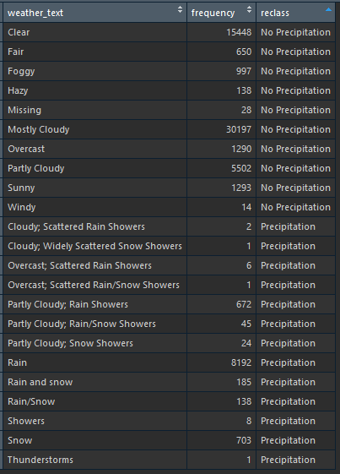

The table above shows the elements of the column on the left along with the frequency and its reclassification. After this was complete, I continued to add feature variables that I believed are useful for predicting whether there will be precipitation or not the next day. I decided to create 3 features: Precipitation Yesterday, Precipitation 2 days ago, and Precipitation Tomorrow (target variable). This was done with the dplyr package using the lead and lag functions. However, since this was a time series dataset, I needed to consider each station separately since they explored the same date range for the 10 years. Now, I began the process of omitting observations that were deemed to be useless or missing information. For example, for the “Predominate weather text all hours” feature, there was a level called “Missing.” This was originally considered as No precipitation when classifying the various levels, however my intention was to omit this later in the data preparation steps since this was a time series dataset. Lastly, I omitted any other rows that had NA values which were a product of the lag and lead functions. Another feature I added was extracting the year from the date column which would be used to create the temporal split for the train/test split. Prior to creating the training and test data set, I had to create a year feature from the “Date” column. This was necessary given that it was a time series data set and using the traditional 70/30 split wouldn’t work. In addition to this, I wanted to consider computing time while running the model. With that being said, I wanted to consider a total of 30 features including the target, “PrecipitationTomorrow”, when running my model. I had a total of 8 features that I wanted to include:
• Station
• SUNRISE_local_AM_fraction_of_day,
• SUNSET_local_PM_hour_fraction_of_day
• Month,
• RainToday
• PrecipitationYesterday
• Precipitation_2_Days_Ago
• RainTomorrow

The other 22 variables would be randomly selected to be considered for the mode. Finally, The training and testing data set would be determined by the following condition:

If any observation had a year value that wasn’t (“2005”, “2006”, “2007”), then it would be added to the training set. Otherwise it would be considered for the test set.

Detailed Findings

Model Testing (1st Attempt)

The machine learning algorithm I will be conducting is a bagged Random Forest Model. A concern prior to running the model that I knew I needed to address was the class imbalance of the data set.
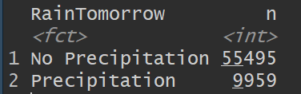

As you can see above from the image, the minority class, Precipitation, was 15.2% of the total observations. Because of this imbalance, the NIR (No information Rate) of the overall data set is 84.8%. We could guess “No Precipitation” for any observation and this would lead to this accuracy. My thoughts on this was to question the validity of the “Predominate weather text all hours” feature. The classification method I used when creating the levels was approached correctly given the other levels described the weather that day to have no precipitation. Other methods to counter the imbalance are SMOTE, undersampling or to use another feature to determine whether there was precipitation that day or not. While the imbalance was an issue, I decided to proceed with running the model prior as it was to assess the performance.

Random Forest (with class imbalance)

Since this was a classification Random Forest model and I was seeking to use bagging, my “mtry” was 5 given the number of features (sqrt(30)) and 1000 trees. As seen below, the table of actual vs predicted for both classes can be summarized as such. Precipitation was misclassified 60.87% of the time while No Precipitation was misclassified only 3.31% of the time. The OOB error rate was 13.08%
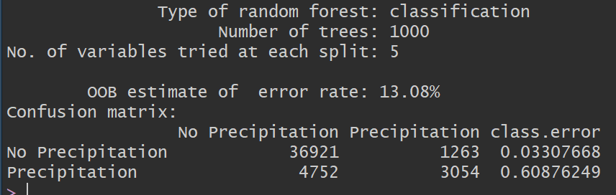
For the Testing set, we can summarize the output with a confusion matrix. The Caret package has a “ConfusionMatrix” function that I utilized with declaring “Precipitation” as the positive class.
The Confusion Matrix output is displayed below which gives us a more in-depth summary of the results for the test set. The overall accuracy of the model is 0.8834 which at first glance seems to be an impressive performance metric. However, this is misleading in our case due to the imbalance of the data set. As a matter of fact, this is described by the NIR (No information Rate) which is 0.8894 (greater than the accuracy of the model). This tells us that we are better with a naïve model that predicts “No Precipitation” for all observations. This is problematic and will be addressed in future revisions to our model. If we dig deeper in the output, we can also see another issue with the metrics. The sensitivity, or the True Positive Rate, is 0.20622 which is terrible considering this class is more important to us vs No Precipitation. The Balanced accuracy which places equal weights on the True Positive Rate and the False Negative Rate is 0.58691.
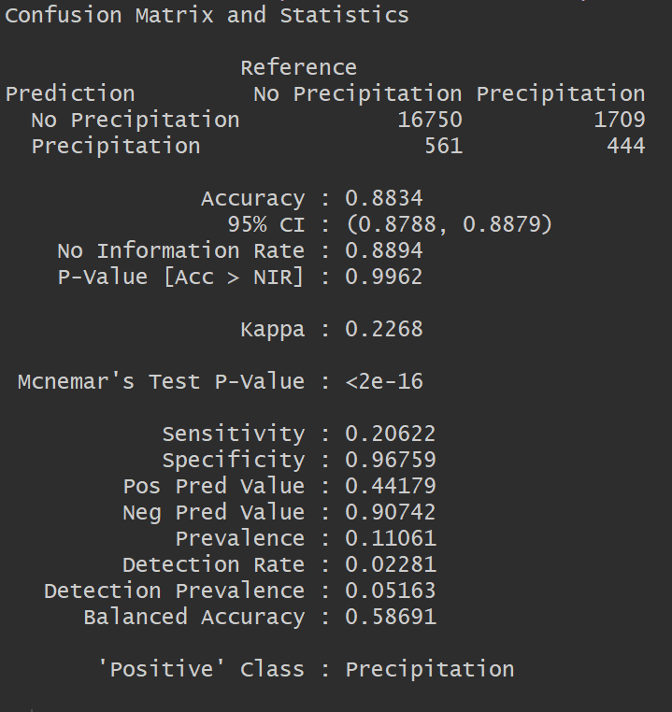
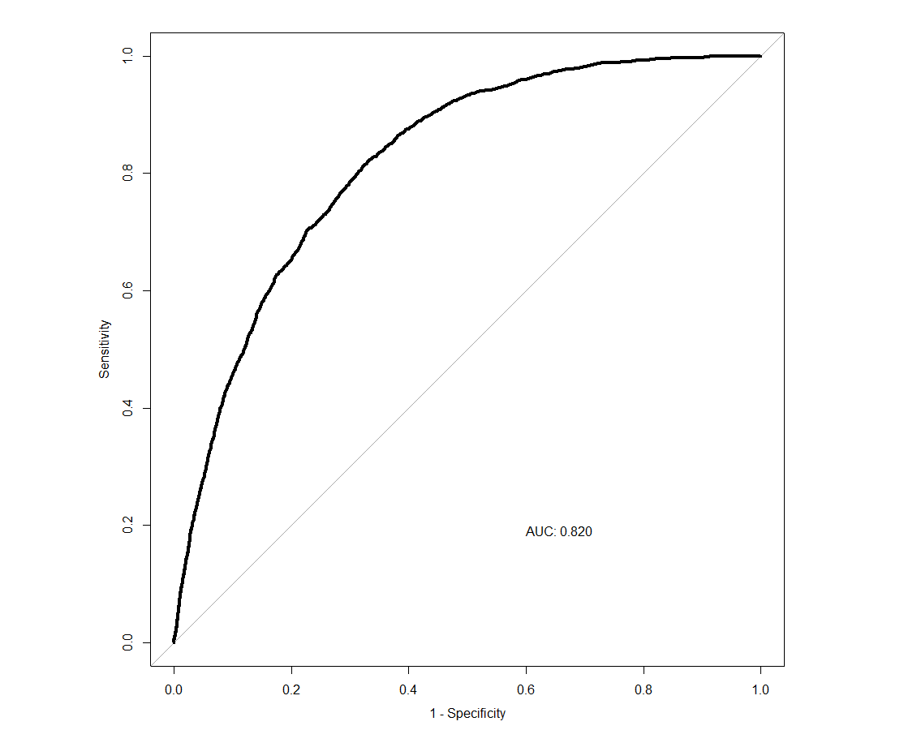
The ROC curve along with the AUC score (0.820) will be useful to compare to other models and to assess which model would be a better selection. While the AUC is good here, this model has shown to be problematic for the reasons mentioned earlier with the sensitivity being extremely low.
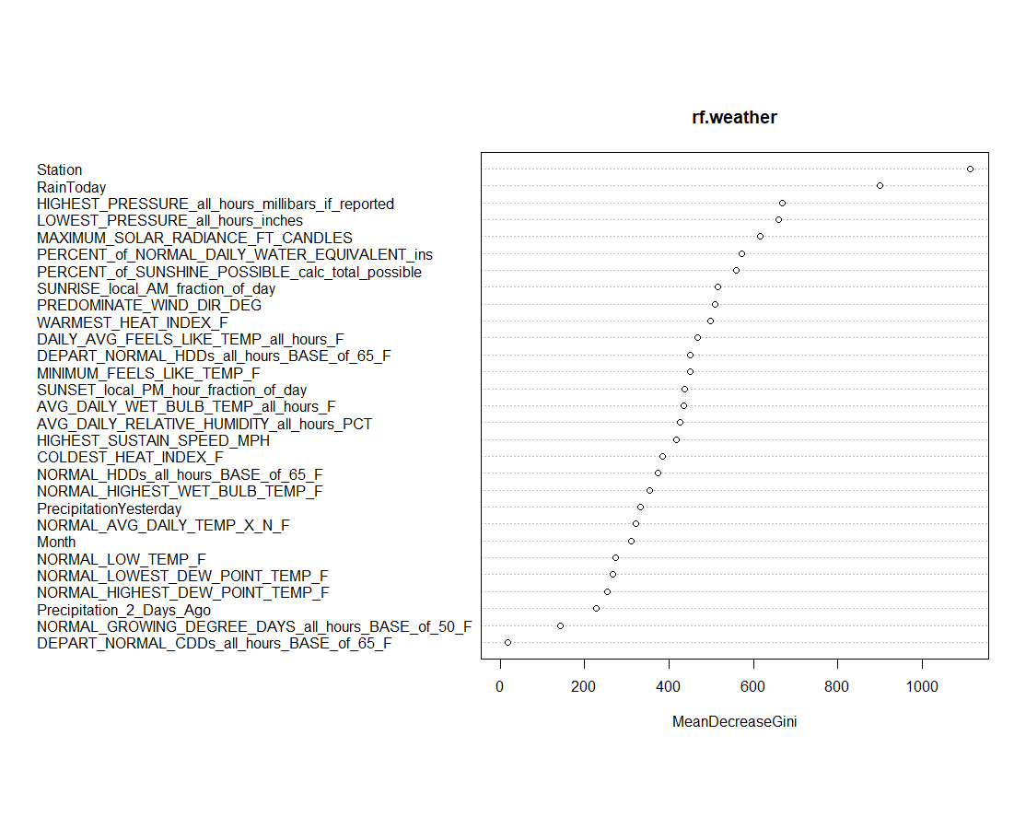
From the VarImpPlot, we can see the clear distinction between the features and the MeanDecreaseGini. Station and Rain Today are the two most important variables compared to the other features. This plot is useful to help experiment with different variables that could be part of the 22 random features that were selected earlier.

Random Forest (Fixing Class Imbalance)

As discussed in the first attempt of running our model, a class imbalance existed due to the “Predominate Weather Text” feature. Instead of performing an oversampling or undersampling technique to address this issue, I elected to utilize a different feature instead to classify whether there was precipitation for any day. The feature, “Observed Daily Water Equivalent Inches”, made a lot of sense to utilize as a substitute since this was a measurement of whether or not there was Precipitation in a day or not. Therefore, a logical test was performed for each observation where if a day had greater than 0 inches of Precipitation that day, then it was assigned “Precipitation.” This technique was validated by looking at a summary table of each station to see how many precipitation days there were in the time range. As you can see below, the column, “num_precipitation” is the number of days of precipitation there were out of “n” days in the dataset. The “fraction_of_precip” column describes the percent each year there is precipitation for each station and the equivalent number of days in a 365-day period. This ranges from 95 – 201 days of annual precipitation (26% - 55%) which seems more plausible for the expected “wet” weather in the Northwest region in the USA.
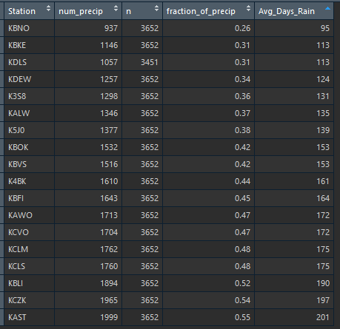
Following the same procedures in the first attempt of running our Random Forest Model, we get a class split of 42%/58% (Precipitation/No Precipitation). This is a great improvement over the first attempt where 85% of the data was No Precipitation, therefore I elected to proceed without any further sampling techniques.
Another feature engineering technique I elected to utilize in this second attempt was to utilize frequency encoding for the following categorical variables: Month, Station, Precipitation Today, Precipitation Yesterday, and Precipitation Two Days Ago. In addition, the other numerical variables and these frequency encoded variables were scaled. Lastly, the temporal split was utilized again except using a 20% train/80% test split for computing time reasons.
The caret package was utilized this time around where tuneGrid and trControl were defined. The results for the Random Forest model can be summarized below with the confusion matrix. While the overall accuracy of the model was only 76%, the NIR was 57% which translates that this model unlike the first was better than the naïve model. This is displayed with the improvement in sensitivity (Precipitation) which was 65%. Also, the balanced accuracy improved significantly to 75%.
The ROC curve was generated for the model and the AUC indicates that this model improved with a score of approximately, 0.84. Lastly, the Variable Importance plot shows that “Percent of Normal Daily Water Equivalent inches” and “Average Daily cloud cover of all hours percent ” were the two most important variables in the model which are different than the first attempt. Overall, this model showed an improvement in performance despite the lower accuracy score compared to the first model. Since predicting whether there will be precipitation the next day is important to us, the revision made to the feature used to predict whether there was precipitation for any day allowed us to have a model that was better than its naïve model and improved the True Positive Rate. This is evident in the AUC score increase.
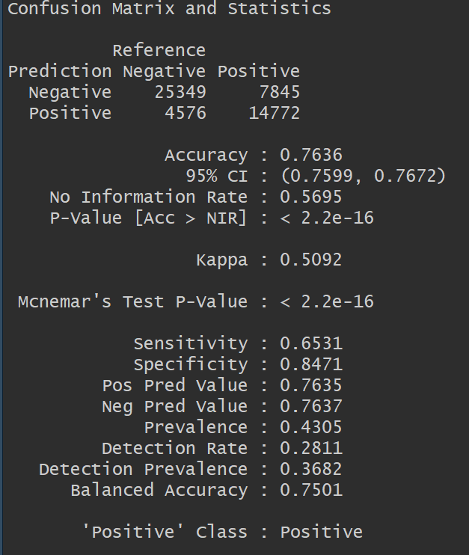
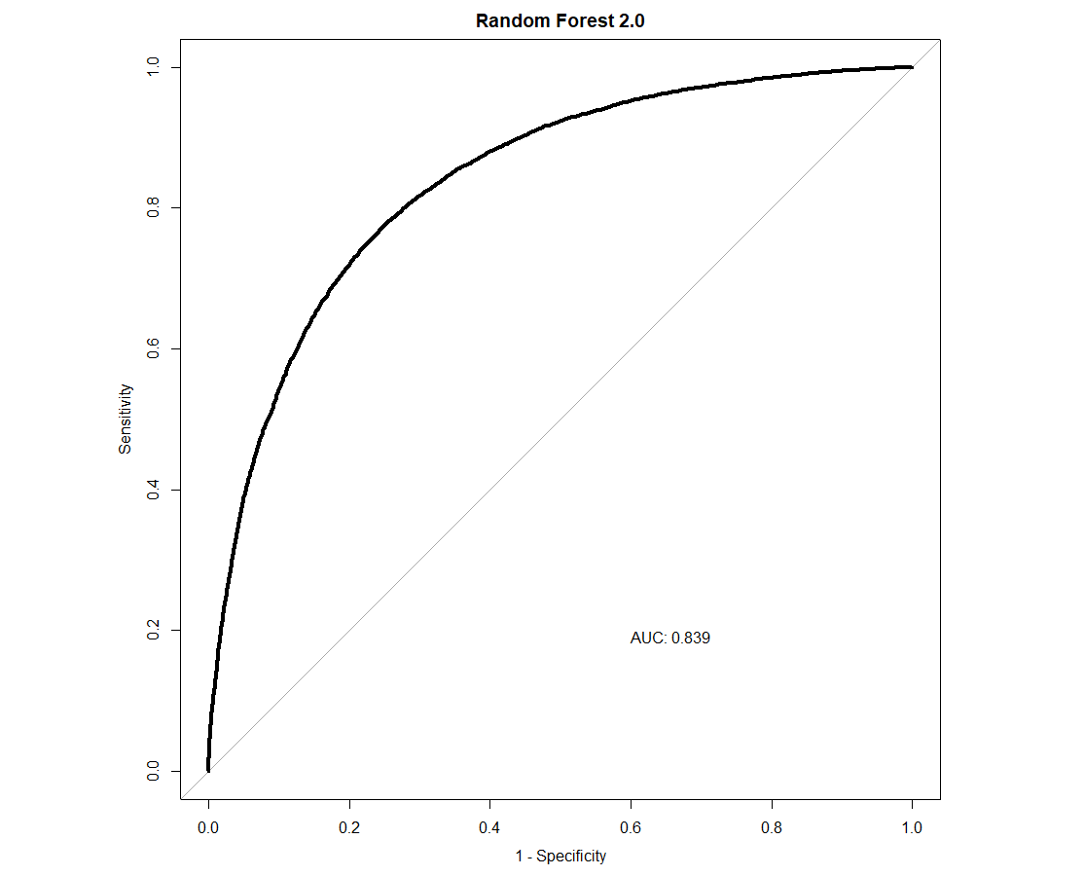
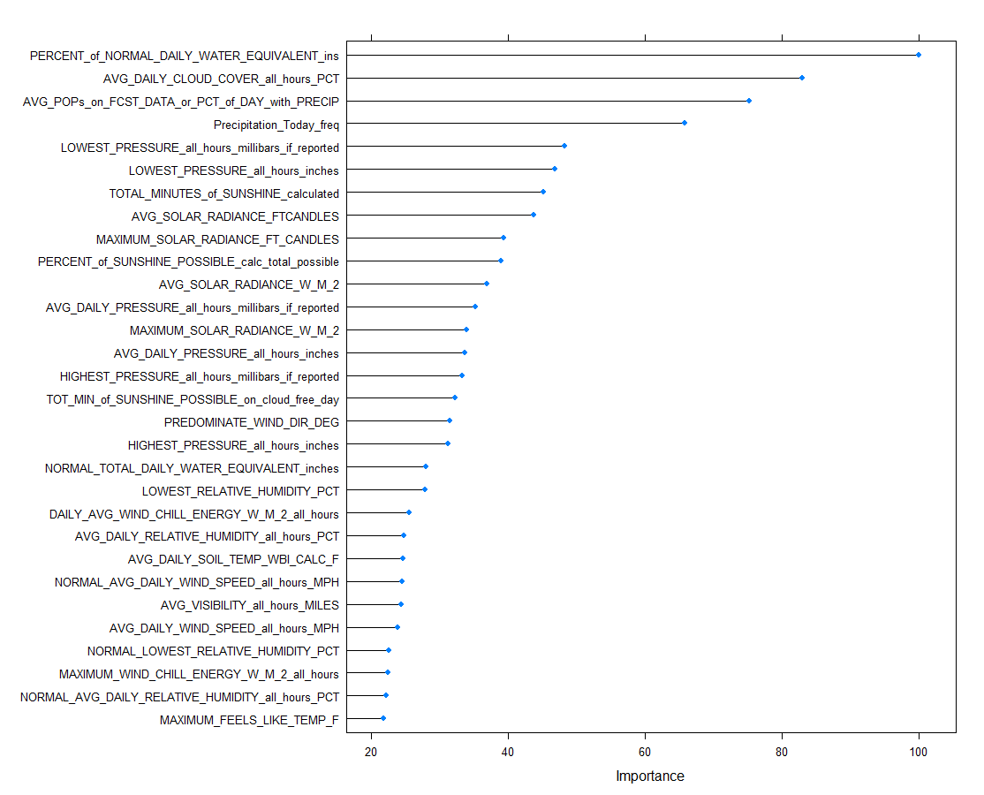

Neural Network Model

To compare, I decided to run a neural network model under the same framework as the last Random Forest Model with the frequency encodings. The tuneGrid and trControl were defined with 10-fold cross validation repeated 5 times with the grid size from 8:10 and a decay of 0.2. The train and test split remained the same. Size 9 with decay 0.2 had the highest accuracy which was picked as the optimal model.
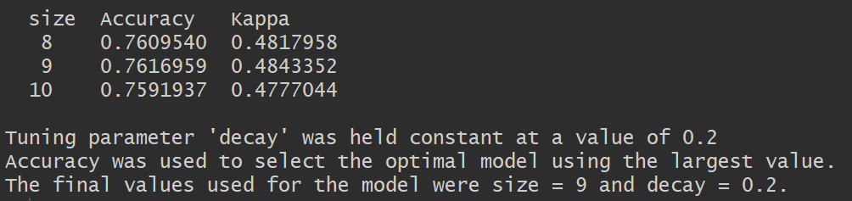
The confusion matrix below can summarize some of the key findings. Similar to the Random Forest model previously, the accuracy rate is essentially the same at 76%. The only difference that I was able to identify between the two models is that the NN model improved with the sensitivity by increasing to 69.5% The ROC curve and AUC score for the Neural Network model regressed just slightly compared to the Random Forest Model.

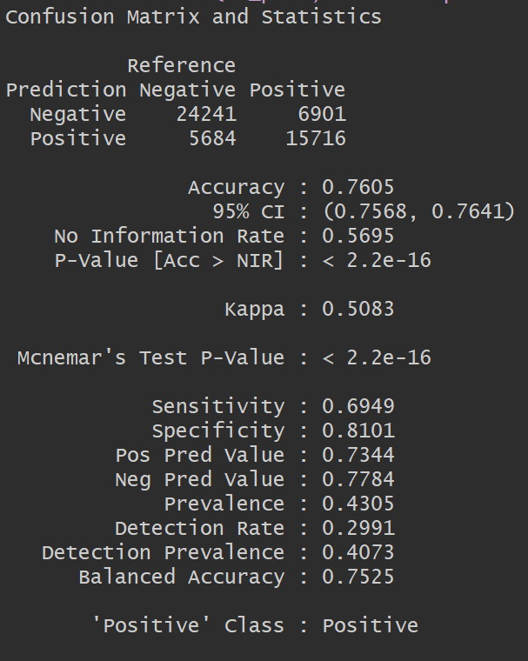
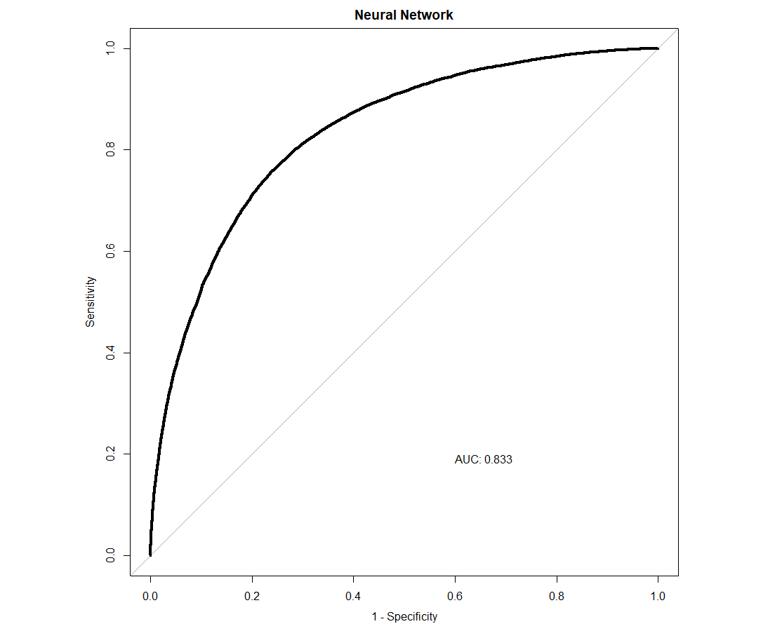
Both the Random Forest and Neural Network model are similar in terms of model performance with the test set, however if the most critical factor is to maximize the predictive power of Precipitation for the next day, then the Neural Network model is superior because of the improvement in TPR over the Random Forest model.

Validity & Reliability Assessment
A discussion of how the accuracy of analysis-driven recommendations should be tested in future implementation.
Based on the analysis of the models performed above as well as the steps taken to arrive at the conclusions, there are a couple of recommendations that I believe could enhance the accuracy of the results. First, the class imbalance was an issue and although I addressed it during the second run of the Random Forest model, this could be improved with a sampling technique such as SMOTE. This is an oversampling method which creates synthetic examples rather than oversampling by replacements. The minority class is over-sampled by taking each minority class sample and introducing synthetic examples along the line segments joining any/all of the k minority nearest neighbors. Some of the advantages are it alleviates overfitting caused by random oversampling, no loss of information as well as it being simple to implement and interpret.
A second recommendation is to implement one-hot encoding of the predictor variables to determine if it improves results. One hot encoding of categorical predictors such as Station, Month, PrecipitationToday, PrecipitationYesterday and Precipitation2DaysAgo can be performed and included in the model analysis. This could be compared to the frequency encoding models.
A third recommendation is to obviously increase the training sample size which was only 10% in the last two model tests compared to 70% in the first Random Forest model. The model could have learned from more data if the training size was bigger and thus lead to improved results. Regardless of the training sample size reduction, the performance results were an improvement over the first test. Lastly, another model variation could have been implemented such as boosting with Random Forest to improve accuracy results.
In conclusion, the research question that was posed at the beginning of the analytical plan of whether we could create a model that could help predict whether there will be Precipitation Tomorrow is an improvement over simply random guessing.

Appendix

weather2.0.R
Hasan Hindi
2020-03-13
library(dplyr)
##
## Attaching package: 'dplyr'
## The following objects are masked from 'package:stats':
##
## filter, lag
## The following objects are masked from 'package:base':
##
## intersect, setdiff, setequal, union
cat("\014")

rm(list=ls())
weather = read.csv("C:/Users/Hasan Hindi/Documents/merrimack/courses/MACHINE LEARNING/project data/weather.csv")
weather$Precipitation_logic = ifelse(weather$OBSERVED_DAILY_WATER_EQUIVALENT_inches>0,1,0)
#Data Splicing to check how many precipitation days there are for each station
w1 = weather %>% group_by(Station) %>% summarise(num_precip = sum(Precipitation_logic == 1))
w2 = weather %>% group_by(Station) %>% tally()
w3 = inner_join(w1,w2,by = "Station")
w3$fraction_of_precip = round(w3$num_precip/w3$n,2)
w3$Avg_Days_Rain = round(w3$fraction_of_precip*365,0)
#Feature engineering to change sunrise and sunset time to fraction of day
weather$Month <- months(as.Date(weather$Date,format = "%m/%d/%Y"))
weather$SUNRISE_local_AM_hour <- as.numeric(substr(weather$SUNRISE_local_AM,1,1))*60
weather$SUNRISE_local_AM_minute = as.numeric(substr(weather$SUNRISE_local_AM,3,4))
weather$SUNRISE_local_AM_fraction_of_day = (weather$SUNRISE_local_AM_hour+weather$SUNRISE_local_AM_minute)/(24*60)
weather$SUNSET_local_PM_hour = as.numeric(substr(weather$SUNSET_local_PM,1,2))*60
weather$SUNSET_local_PM_minute = as.numeric(substr(weather$SUNSET_local_PM,4,5))
weather$SUNSET_local_PM_hour_fraction_of_day = (weather$SUNSET_local_PM_hour+weather$SUNSET_local_PM_minute)/(24*60)
# Creates a dataframe to filter out any features with missing values
# less than 1000 observations but more than zero.
cols = as.array(colnames(weather))
stored = c()
for (i in 1:length(cols)){
stored = c(stored,sum(is.na(weather[,cols[i]])))
}
cols_with_missing_to_fill = data.frame(colnames = cols,missing = stored)
cols_with_missing_to_fill = cols_with_missing_to_fill %>% filter(missing < 1000 & missing > 0 )
## Fills NA values for those missing values with mean of those features by each station.
for (i in as.array(cols_with_missing_to_fill$colnames)){
for (j in which(is.na(weather[,i]))){
station.name = weather[j,"Station"]
row_num_station = which(weather$Station == station.name)
mean_of_station_for_i = mean(weather[row_num_station,i],na.rm = TRUE)
weather[j,i] <- mean_of_station_for_i
}
}
#Removing any features with too many NA values or if those features have homogeneous data (like all zeroes)
weather$MINIMUM_SOLAR_RADIANCE_W_M_2 = NULL
weather$MINIMUM_SOLAR_RADIANCE_FT_CANDLES = NULL
weather$TOTAL_MINUTES_of_SUNSHINE_if_observed = NULL
weather$SUNRISE_local_AM = NULL
weather$SUNSET_local_PM = NULL
weather$FORECASTED_DFN_TOTAL_PRECIP_inches = NULL
weather$SUNRISE_local_AM_hour = NULL
weather$SUNRISE_local_AM_minute = NULL
weather$SUNSET_local_PM_hour = NULL
weather$SUNSET_local_PM_minute = NULL
weather$CALENDAR_DAY_TOTAL_HOURS_of_PRECIP = NULL
weather$HIGH_TEMP_30_YR_5th_PERCENTILE = NULL
weather$HIGH_TEMP_30_YR_30th_PERCENTILE = NULL
weather$HIGH_TEMP_30_YR_50th_PERCENTILE = NULL
weather$HIGH_TEMP_30_YR_70th_PERCENTILE = NULL
weather$HIGH_TEMP_30_YR_95th_PERCENTILE = NULL
weather$LOW_TEMP_30_YR_5th_PERCENTILE = NULL
weather$LOW_TEMP_30_YR_30th_PERCENTILE = NULL
weather$LOW_TEMP_30_YR_50th_PERCENTILE = NULL
weather$LOW_TEMP_30_YR_70th_PERCENTILE = NULL
weather$LOW_TEMP_30_YR_95th_PERCENTILE = NULL
weather$Month = as.factor(weather$Month)
weather$Precipitation_logic = ifelse(weather$Precipitation_logic == 1,"Precipitation","No Precipitation")
weather$Precipitation_Today = weather$Precipitation_logic
weather$Precipitation_logic = NULL
funGetStationWeatherPastAndPresent <- function(station_list){
weather2 = weather[0,]
for (i in station_list){
df <- weather %>% filter(weather$Station == i)
df$PrecipitationYesterday <- lag(df$Precipitation_Today,1)
df$Precipitation2DaysAgo <- lag(df$Precipitation_Today,2)
df$PrecipitationTomorrow <- lead(df$Precipitation_Today,1)
weather2 <- rbind(weather2,df)
}
assign("weather2",weather2,.GlobalEnv)
}
funGetStationWeatherPastAndPresent(levels(weather$Station))
weather2$Precipitation2DaysAgo <- as.factor(weather2$Precipitation2DaysAgo)
weather2$PrecipitationYesterday <- as.factor(weather2$PrecipitationYesterday)
weather2$PrecipitationTomorrow <- as.factor(weather2$PrecipitationTomorrow)
weather2$Precipitation_Today <- as.factor(weather2$Precipitation_Today)
weather2$year = as.factor(format(as.Date(weather2$Date, format="%m/%d/%Y"),"%Y"))
weather2$Date = NULL
weather2 = na.omit(weather2)
weather2$OBSERVED_DAILY_WATER_EQUIVALENT_inches = NULL
weather2$PREDOMINATE_WEATHER_TEXT_all_hours = NULL
weather2$SUNRISE_local_AM_fraction_of_day = NULL
weather2$SUNSET_local_PM_hour_fraction_of_day = NULL
library(caret)
## Warning: package 'caret' was built under R version 3.6.2
## Loading required package: lattice
## Loading required package: ggplot2
set.seed(123)
train.years = sample(levels(weather2$year),2)
train <- weather2[which(weather2$year %in% train.years),]
test <- weather2[-which(weather2$year %in% train.years),]
train$year = NULL
test$year = NULL
levels(train$PrecipitationTomorrow)[levels(train$PrecipitationTomorrow)=="Precipitation"] <- "Positive"
levels(train$PrecipitationTomorrow)[levels(train$PrecipitationTomorrow)=="No Precipitation"] <- "Negative"
recommended_mtry <- floor(sqrt(ncol(train[,-which(colnames(train) == "PrecipitationTomorrow")])))
rfGrid <- expand.grid(mtry = c(recommended_mtry-2, recommended_mtry, recommended_mtry+2))
rfControl <- trainControl(method = "oob",classProbs = TRUE)
freq_enc <- function(variable, level) { nrow(train[train[, variable]==level, ]) }
station_freq <- mapply(freq_enc, variable = "Station", level = levels(weather2$Station), USE.NAMES = FALSE)
names(station_freq) <- levels(weather2$Station)
Month_freq <- mapply(freq_enc, variable = "Month", level = levels(weather2$Month), USE.NAMES = FALSE)
names(Month_freq) <- levels(weather2$Month)
Precipitation_Today_freq <- mapply(freq_enc, variable = "Precipitation_Today", level = levels(weather2$Precipitation_Today), USE.NAMES = FALSE)
names(Precipitation_Today_freq) <- levels(weather2$Precipitation_Today)
Precipitation_Yesterday_freq <- mapply(freq_enc, variable = "PrecipitationYesterday", level = levels(weather2$PrecipitationYesterday), USE.NAMES = FALSE)
names(Precipitation_Yesterday_freq) <- levels(weather2$PrecipitationYesterday)
Precipitation2DaysAgo_freq <- mapply(freq_enc, variable = "Precipitation2DaysAgo", level = levels(weather2$Precipitation2DaysAgo), USE.NAMES = FALSE)
names(Precipitation2DaysAgo_freq) <- levels(weather2$Precipitation2DaysAgo)
train$station_freq <- 0
for (level in levels(train$Station)){
train[train[, "Station"]==level, "station_freq"] <- station_freq[level]
}
train$Month_freq <- 0
for (level in levels(train$Month)){
train[train[, "Month"]==level, "Month_freq"] <- Month_freq[level]
}
train$Precipitation_Today_freq <- 0
for (level in levels(train$Precipitation_Today)) {
train[train[, "Precipitation_Today"]==level, "Precipitation_Today_freq"] <- Precipitation_Today_freq[level]
}
train$Precipitation_Yesterday_freq <- 0
for (level in levels(train$PrecipitationYesterday)) {
train[train[, "PrecipitationYesterday"]==level, "Precipitation_Yesterday_freq"] <- Precipitation_Yesterday_freq[level]
}
train$Precipitation2DaysAgo_freq <- 0
for (level in levels(train$Precipitation2DaysAgo)) {
train[train[, "Precipitation2DaysAgo"]==level, "Precipitation2DaysAgo_freq"] <- Precipitation2DaysAgo_freq[level]
}
#test
test$station_freq <- 0
for (level in levels(train$Station)){
test[test[, "Station"]==level, "station_freq"] <- station_freq[level]
}
test$Month_freq <- 0
for (level in levels(train$Month)){
test[test[, "Month"]==level, "Month_freq"] <- Month_freq[level]
}
test$Precipitation_Today_freq <- 0
for (level in levels(train$Precipitation_Today)) {
test[test[, "Precipitation_Today"]==level, "Precipitation_Today_freq"] <- Precipitation_Today_freq[level]
}
test$Precipitation_Yesterday_freq <- 0
for (level in levels(train$PrecipitationYesterday)) {
test[test[, "PrecipitationYesterday"]==level, "Precipitation_Yesterday_freq"] <- Precipitation_Yesterday_freq[level]
}
test$Precipitation2DaysAgo_freq <- 0
for (level in levels(train$Precipitation2DaysAgo)) {
test[test[, "Precipitation2DaysAgo"]==level, "Precipitation2DaysAgo_freq"] <- Precipitation2DaysAgo_freq[level]
}
test[, 2:93] <- scale(test[, 2:93], center = apply(train[, 2:93], 2, mean), scale = apply(train[, 2:93], 2, sd))
train[, 2:93] <- scale(train[, 2:93])
test[, 99:103] <- scale(test[, 99:103], center = apply(train[, 99:103], 2, mean), scale = apply(train[, 99:103], 2, sd))
train[, 99:103] <- scale(train[, 99:103])
rf_model <- train(x = train[,c(2:93,99:103)],
y = train[,98],
method = "rf",
tuneGrid = rfGrid,
trControl = rfControl,
importance = TRUE,
trace = FALSE,ntrees = 500)
levels(test$PrecipitationTomorrow)[levels(test$PrecipitationTomorrow)=="Precipitation"] <- "Positive"
levels(test$PrecipitationTomorrow)[levels(test$PrecipitationTomorrow)=="No Precipitation"] <- "Negative"
rf_pred <- predict(rf_model,newdata = test[,c(2:93,99:103)])
rf_probs = predict(rf_model,newdata = test[,c(2:93,99:103)],
type = "prob")
confusionMatrix(rf_pred,test$PrecipitationTomorrow,positive = "Positive")
## Confusion Matrix and Statistics
##
## Reference
## Prediction Negative Positive
## Negative 25349 7845
## Positive 4576 14772
##
## Accuracy : 0.7636
## 95% CI : (0.7599, 0.7672)
## No Information Rate : 0.5695
## P-Value [Acc > NIR] : < 2.2e-16
##
## Kappa : 0.5092
##
## Mcnemar's Test P-Value : < 2.2e-16
##
## Sensitivity : 0.6531
## Specificity : 0.8471
## Pos Pred Value : 0.7635
## Neg Pred Value : 0.7637
## Prevalence : 0.4305
## Detection Rate : 0.2811
## Detection Prevalence : 0.3682
## Balanced Accuracy : 0.7501
##
## 'Positive' Class : Positive
##
library(classifierplots)
## Warning: package 'classifierplots' was built under R version 3.6.3
## Loading required package: data.table
## Warning: package 'data.table' was built under R version 3.6.3
##
## Attaching package: 'data.table'
## The following objects are masked from 'package:dplyr':
##
## between, first, last
library(ROCR)
## Warning: package 'ROCR' was built under R version 3.6.2
## Loading required package: gplots
## Warning: package 'gplots' was built under R version 3.6.2
##
## Attaching package: 'gplots'
## The following object is masked from 'package:stats':
##
## lowess
library(pROC)
## Type 'citation("pROC")' for a citation.
##
## Attaching package: 'pROC'
## The following objects are masked from 'package:stats':
##
## cov, smooth, var
par(pty = "s")
roc(test$PrecipitationTomorrow,rf_probs[,"Positive"],plot = TRUE,legacy.axes = TRUE,
lwd = 4,print.auc = TRUE,print.auc.x = 0.4,print.auc.y = 0.2, main = "Random Forest 2.0")
## Setting levels: control = Negative, case = Positive
## Setting direction: controls < cases
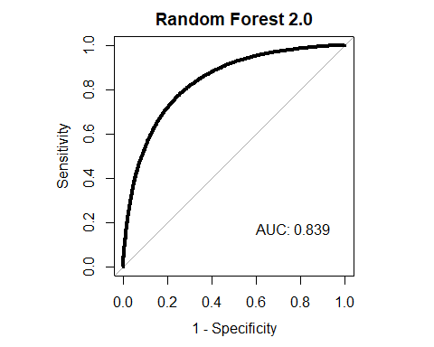
##
## Call:
## roc.default(response = test$PrecipitationTomorrow, predictor = rf_probs[, "Positive"], plot = TRUE, legacy.axes = TRUE, lwd = 4, print.auc = TRUE, print.auc.x = 0.4, print.auc.y = 0.2, main = "Random Forest 2.0")
##
## Data: rf_probs[, "Positive"] in 29925 controls (test$PrecipitationTomorrow Negative) < 22617 cases (test$PrecipitationTomorrow Positive).
## Area under the curve: 0.8391
rf_varImp <- varImp(rf_model, type = 2)
plot(rf_varImp,top = 30)
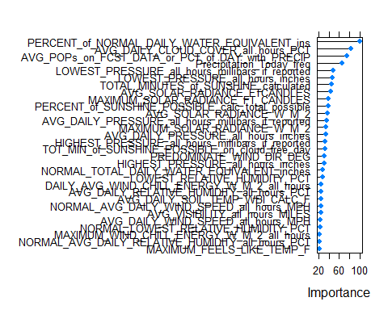
nnGrid <- expand.grid(size = 8:10, decay = 0.2)
nnControl <- trainControl(method = "repeatedcv", repeats = 5, classProbs = TRUE)
nn_model <- train(x = train[,c(2:93,99:103)],
y = train[,98],
method = "nnet",
tuneGrid = nnGrid,
trControl = nnControl,
trace = FALSE)
nn_pred <- predict(nn_model,newdata = test[,c(2:93,99:103)])
nn_probs = predict(nn_model,newdata = test[,c(2:93,99:103)],
type = "prob")
confusionMatrix(nn_pred,test$PrecipitationTomorrow,positive = "Positive")
## Confusion Matrix and Statistics
##
## Reference
## Prediction Negative Positive
## Negative 24241 6901
## Positive 5684 15716
##
## Accuracy : 0.7605
## 95% CI : (0.7568, 0.7641)
## No Information Rate : 0.5695
## P-Value [Acc > NIR] : < 2.2e-16
##
## Kappa : 0.5083
##
## Mcnemar's Test P-Value : < 2.2e-16
##
## Sensitivity : 0.6949
## Specificity : 0.8101
## Pos Pred Value : 0.7344
## Neg Pred Value : 0.7784
## Prevalence : 0.4305
## Detection Rate : 0.2991
## Detection Prevalence : 0.4073
## Balanced Accuracy : 0.7525
##
## 'Positive' Class : Positive
##
par(pty = "s")
roc(test$PrecipitationTomorrow,nn_probs[,"Positive"],plot = TRUE,legacy.axes = TRUE,
lwd = 4,print.auc = TRUE,print.auc.x = 0.4,print.auc.y = 0.2, main = "Neural Network")
## Setting levels: control = Negative, case = Positive
## Setting direction: controls < cases
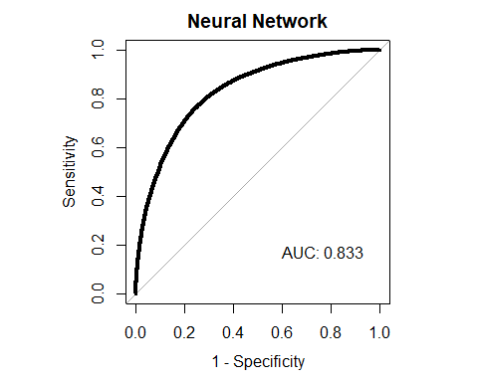
##
## Call:
## roc.default(response = test$PrecipitationTomorrow, predictor = nn_probs[, "Positive"], plot = TRUE, legacy.axes = TRUE, lwd = 4, print.auc = TRUE, print.auc.x = 0.4, print.auc.y = 0.2, main = "Neural Network")
##
## Data: nn_probs[, "Positive"] in 29925 controls (test$PrecipitationTomorrow Negative) < 22617 cases (test$PrecipitationTomorrow Positive).
## Area under the curve: 0.8333

